**TechVerito Assessment**

Building infrastructure as shown in below architecture

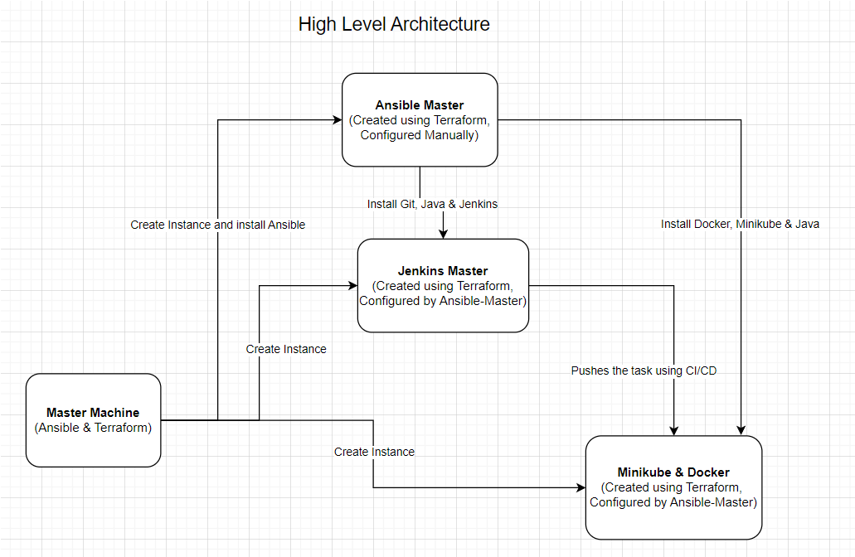

Manually launching an instance of ubuntu OS named(Master-Machine) with Ansible & terraform installed on it.

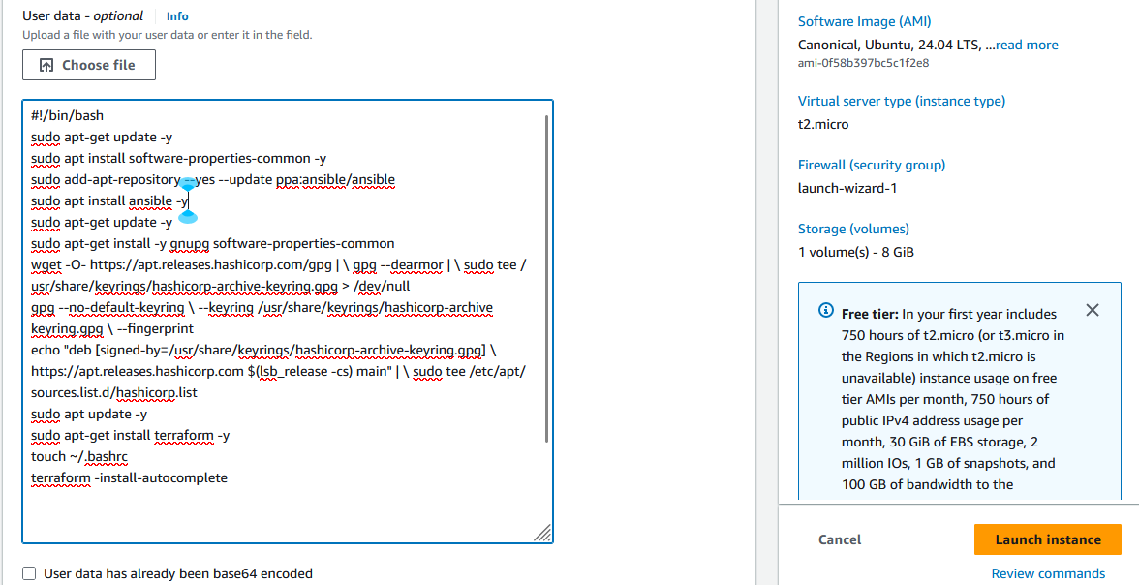

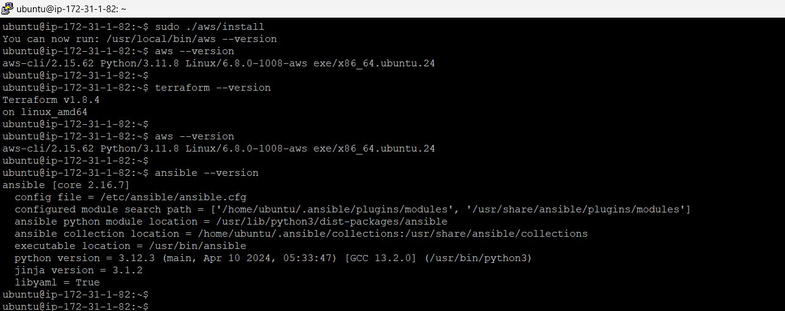

Now, creating a terraform file and modules to setup AWS infrastructure along with that created 2 bash scripts to execute in Jenkins_master & Minikube_docker instances

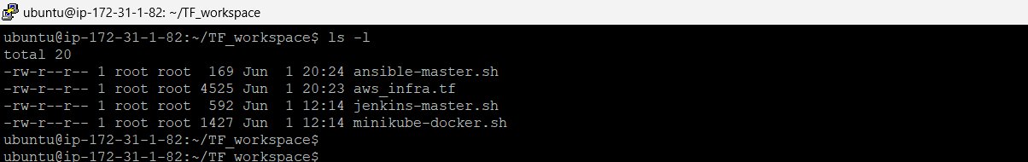

Initialize the terraform in the directory:

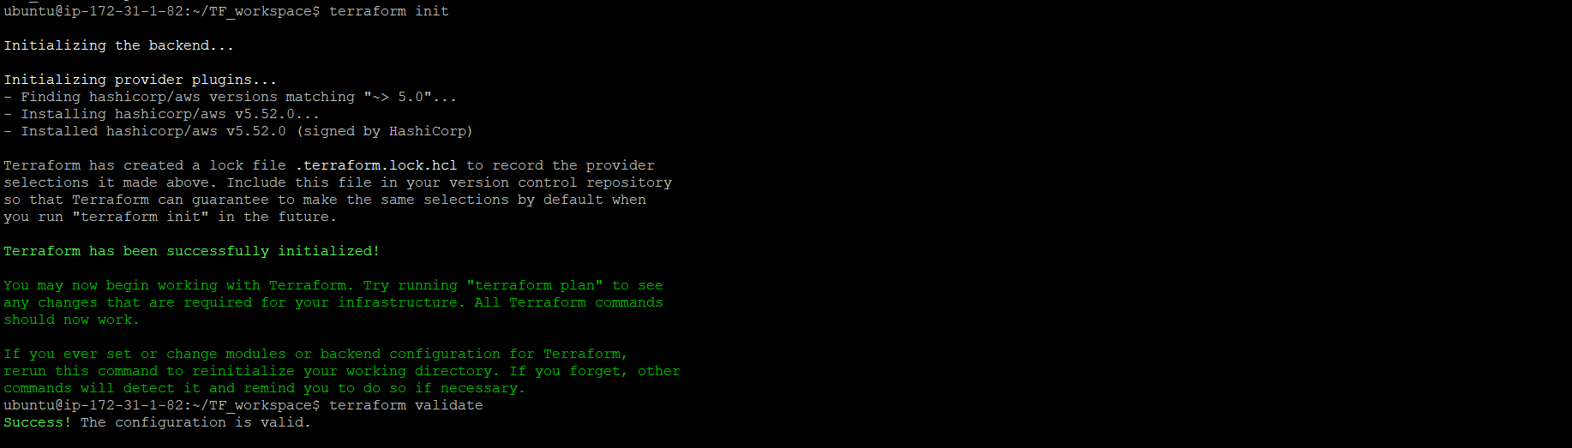

Terraform plan – executed successfully

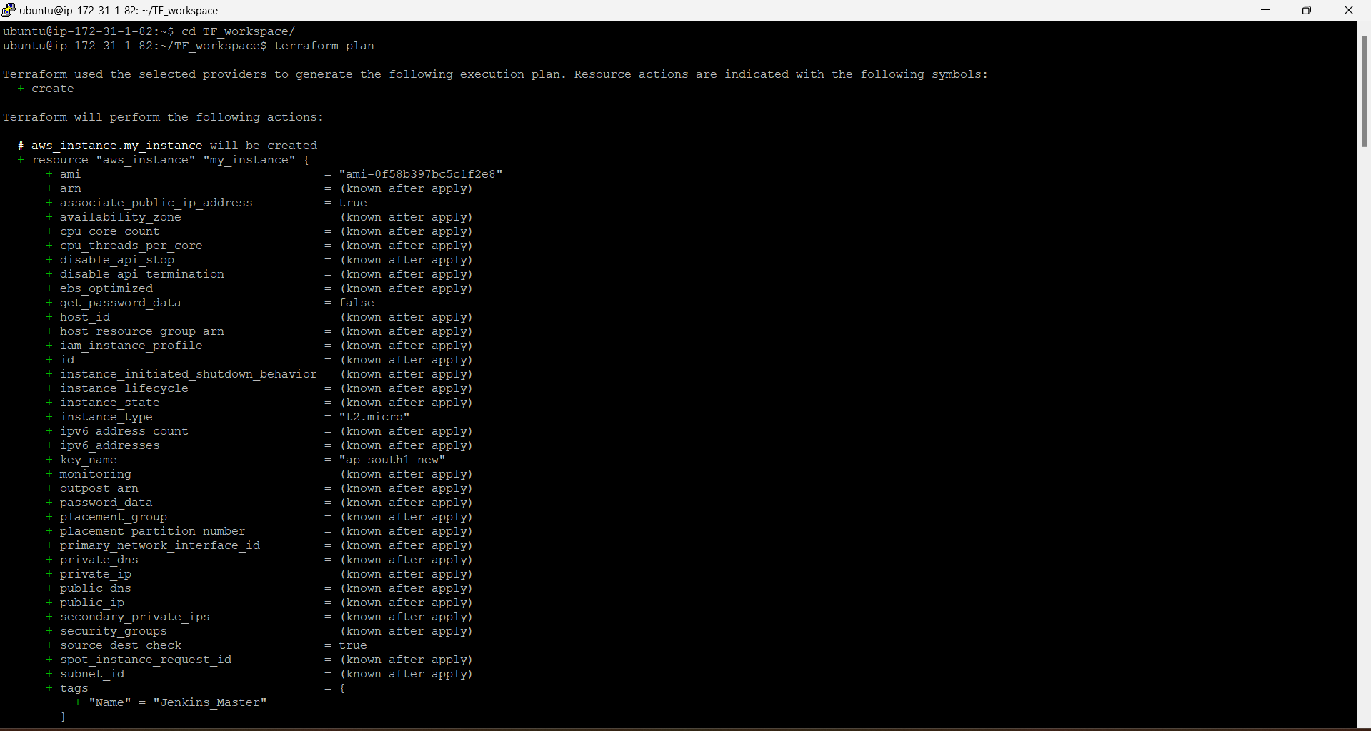

Terraform apply – executed successfully

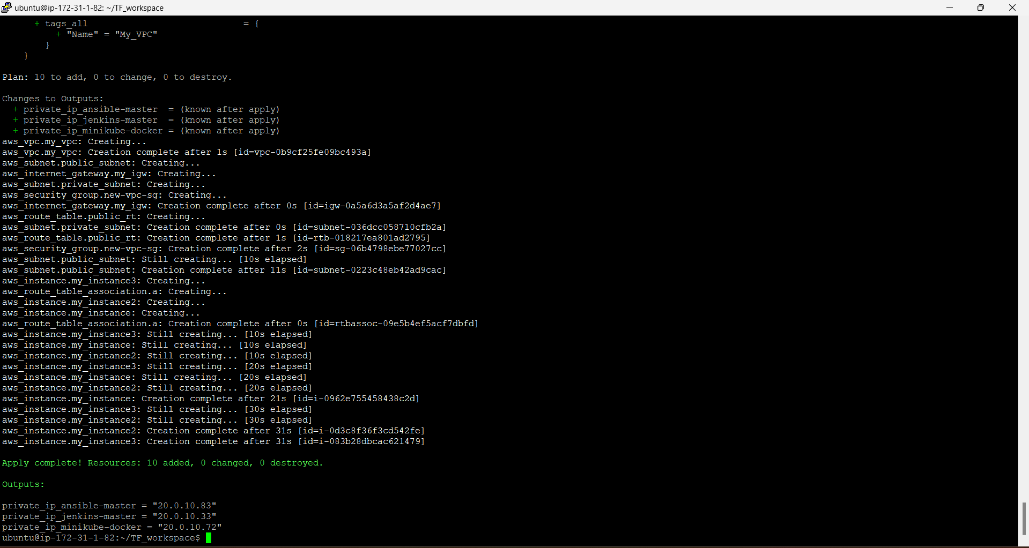

All 3 required instance launched

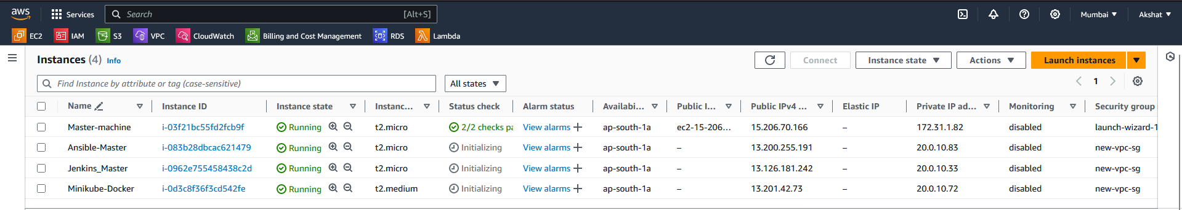

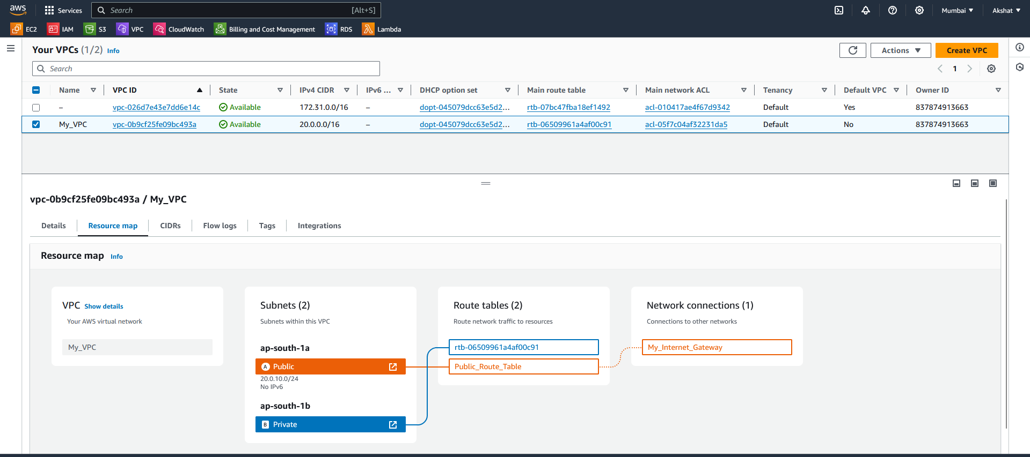

Below is the Jenkins Job structure

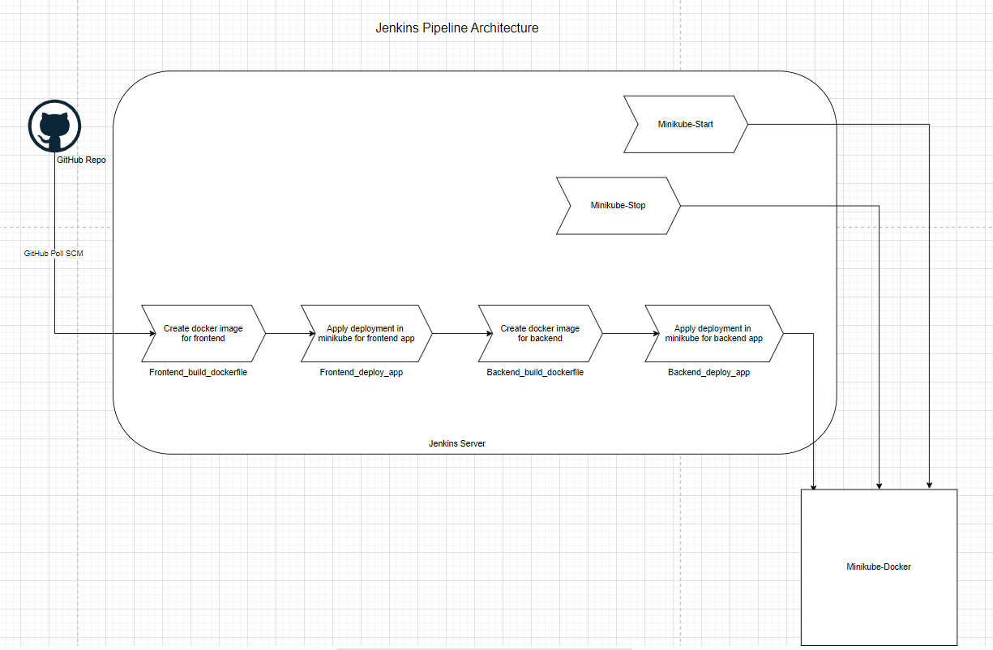

View of launched & running instances in AWS.

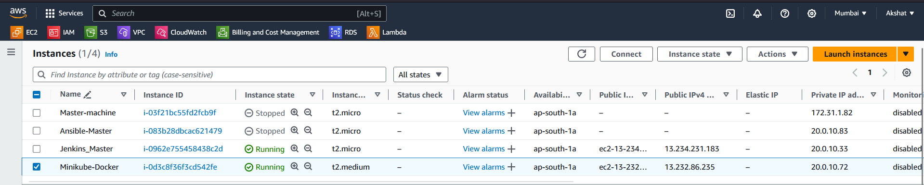

All Jenkins jobs are running fine, all the scripts are getting executed successfully in the minikube cluster through Jenkins jobs.

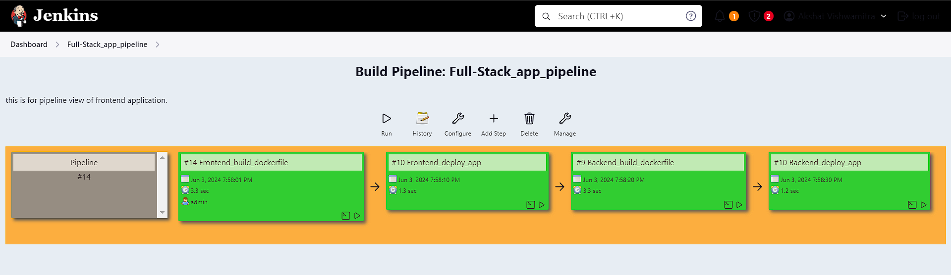

Both, frontend & backend applications are accessible through browser. But unable to add & fetch data into the database.

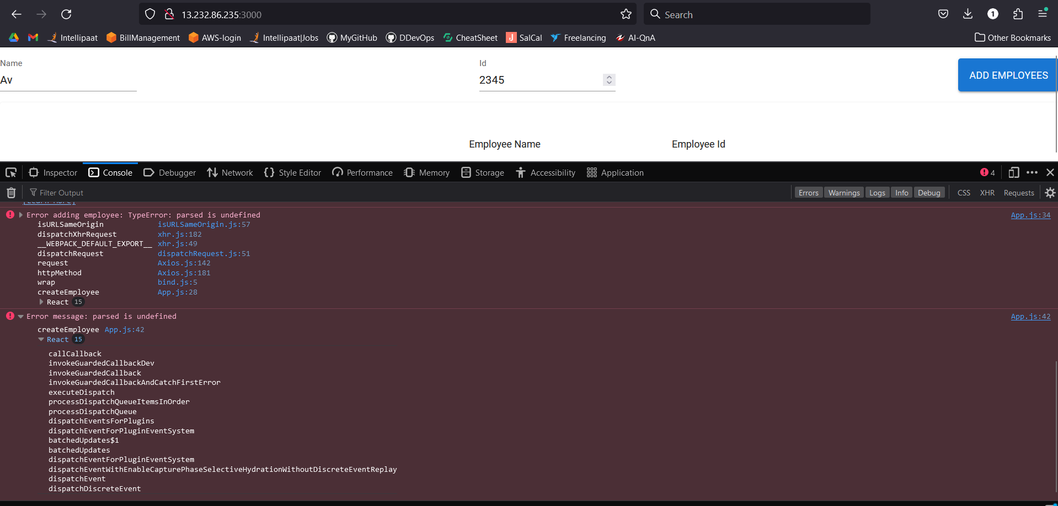

Also, its not reflecting in backend application.

